How do I Join?
VISIT
join.elks.org

Get involved

Look at your ELK membership as a means for a better future for our youth
Look at your ELK membership as a means for a better future for your community
Look at your ELK membership as a means for a better future for our veterans
Look at your ELK membership as a means for a better future for our nation

Over 1900 Lodges across the Nation

If you are an ELK anywhere,
You are an ELK everywhere!
State and National Conventions
MEMBERSHIP

Membership in the Benevolent and Protective Order of Elks offers many benefits and rewards. Not only do you get the satisfaction and pleasure of giving back to your community in a meaningful way through all the charitable work our lodges engage in, you get to do it with

the Best People On Earth.
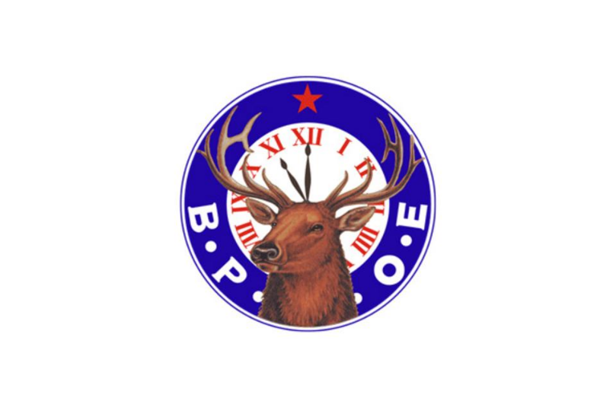
Make a Difference Pass the TORCH!

Make a Difference Find Your Passion
elks.org

Copyright ©2023 BPO Elks.

Your
Journey Begins Now
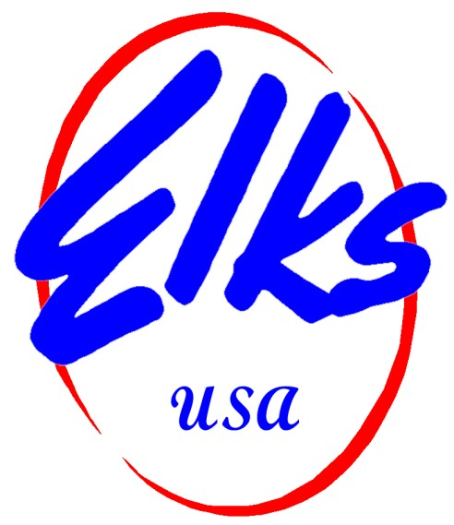

The Premier Charitable
and
Patriotic Organization
In the Nation

ABQ Elks Lodge #461

2430 Centre Ave SE

Albuquerque, NM 87106
(505) 243-7895
E-mail: elkslodge461@gmail.com
“Albuquerque Elks Lodge #461”
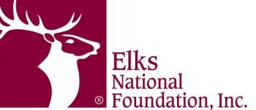
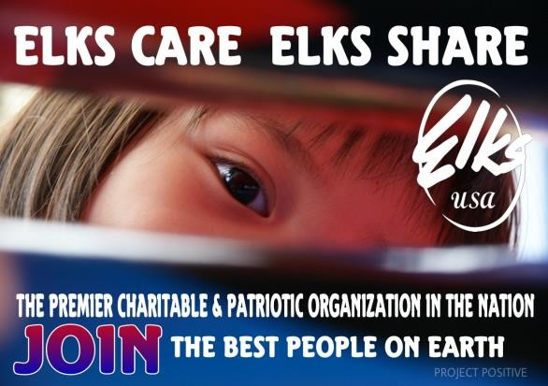

Elks are community.
No matter where you go in the country, an Elks Lodge is right around the corner. With more than 850,000 members and 1,900 Lodges nationwide, Elks are providing charitable services that help build stronger communities.
Elks Lodges bring so much more to their communities than just a building, golf course or pool. They are places where neighbors come together, families share meals, and children grow up.
Elks invest in their communities through programs that help children grow up healthy and drug-free, by undertaking projects that address unmet need, and by honoring the service and sacrifice of our veterans.

The mission of the ENF is to help Elks build stronger communities. We fulfill this pledge by investing in communities where Elks live and work. We provide tomorrow's leaders, our youth, with lifelong skills; honor the Elks' pledge to never forget our veterans; help the state Elks associations accomplish their charitable objectives; and fund projects that improve the quality of life in local Elks communities.

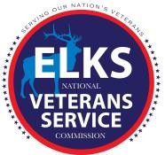
The Elks are committed to their mission, “So long as there are veterans, the Benevolent and Protective Order of Elks will never forget them.” The Veterans Service Commission takes that pledge one step further, and promises service to our nation's veterans and military members, with a special focus on service to those in need.
As the needs of today’s veterans changed, so have the Elks’ programs. Today, the Elks National Veterans Service Commission has many exciting programs and partnerships catering to veterans and military members and their families.

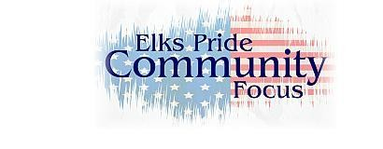

The New Mexico Elks Cerebral Palsy Commission
The Cerebral Palsy Commission has implemented a program emphasizing “grass roots” participation from New Mexico's Local Lodges. As an association, the New Mexico Elks are able to help families who have special needs afford the essential equipment, services and tools they need to improve the quality of their everyday life and that of their children. They have made great strides in affecting change in their community and helping children who are burdened by Cerebral Palsy.
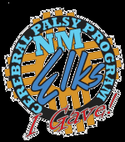

Albuquerque ELKS
“Give back to the Community”
Scholarships
Sponsor School Sports Programs Americanism Essay Contest Kids Drug Awareness Program
Veterans Programs

